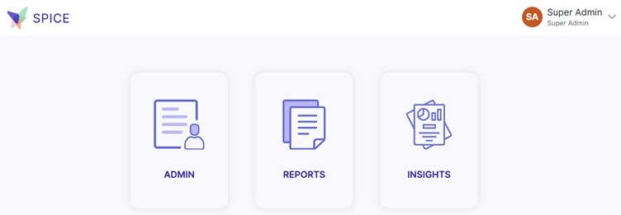
1. Admin Tab: This section is usually for managing users, settings, and system configurations.
Common actions include:
- Adding or removing users
- Changing user roles/permissions
- Updating system settings
- Managing security and access controls
2. Reports Tab: This is where you can generate, view, and download reports.
Typical functionalities:
- Viewing pre-built reports
- Customizing reports with filters
- Exporting reports (e.g., CSV, PDF)
- Scheduling automatic report generation
3. Insights Tab: This section provides analytics and visual dashboards to help you understand trends and performance.
Key features might include:
- Interactive charts and graphs
- KPIs and performance metrics
- Predictive analytics
- Data exploration tools

1. Admin Portal Overview:
The COMEMR Admin Portal is a powerful tool that enables administrators to manage users, facilities, workflows, medication databases, and lab test databases, and customize the platform at the region and account levels.

2. Key Features:
• User Management: Create, edit, and deactivate user profiles. Assign roles and permissions for proper access control.
• Facility Management: Set up and maintain facilities, manage details, and assist with account setups and resets.
• Workflow Customization: Enable or disable clinical workflows such as hypertension, diabetes, mental health, maternal health, HIV, TB, and malaria.
• Medication Database Management: Super Admin manages medication database, adding country-relevant medication information.
• Region-Level Customization: Configure settings and features based on geographical regions to align with local healthcare practices.
• Account-Level Workflow Customization: Customize workflows at the account level to suit organizational requirements.

3. User Roles:
• Super Admin: Full control over regions, accounts, customization, and user management.
• Regional Admin: Manages accounts in specific regions, assists with facility setup and account management.
• Account Admin: Handles account setup, operating unit management, and user creation.
• OU Admin: Creates sites, groups, and users at the Operating Unit level and manages administrative tasks.

